# Hands-on Lab: String Patterns, Sorting and Grouping in MySQL

CREATE TABLE EMPLOYEES (

EMP_ID CHAR(9) NOT NULL,

F_NAME VARCHAR(15) NOT NULL,

L_NAME VARCHAR(15) NOT NULL,

SSN CHAR(9),

B_DATE DATE,

SEX CHAR,

ADDRESS VARCHAR(30),

JOB_ID CHAR(9),

SALARY DECIMAL(10,2),

MANAGER_ID CHAR(9),

DEP_ID CHAR(9) NOT NULL,

PRIMARY KEY (EMP_ID));

CREATE TABLE JOB_HISTORY (

EMPL_ID CHAR(9) NOT NULL,

START_DATE DATE,

JOBS_ID CHAR(9) NOT NULL,

DEPT_ID CHAR(9),

PRIMARY KEY (EMPL_ID,JOBS_ID));

CREATE TABLE JOBS (

JOB_IDENT CHAR(9) NOT NULL,

JOB_TITLE VARCHAR(30),

MIN_SALARY DECIMAL(10,2),

MAX_SALARY DECIMAL(10,2),

PRIMARY KEY (JOB_IDENT));

CREATE TABLE DEPARTMENTS (

DEPT_ID_DEP CHAR(9) NOT NULL,

DEP_NAME VARCHAR(15) ,

MANAGER_ID CHAR(9),

LOC_ID CHAR(9),

PRIMARY KEY (DEPT_ID_DEP));

CREATE TABLE LOCATIONS (

LOCT_ID CHAR(9) NOT NULL,

DEP_ID_LOC CHAR(9) NOT NULL,

PRIMARY KEY (LOCT_ID,DEP_ID_LOC));

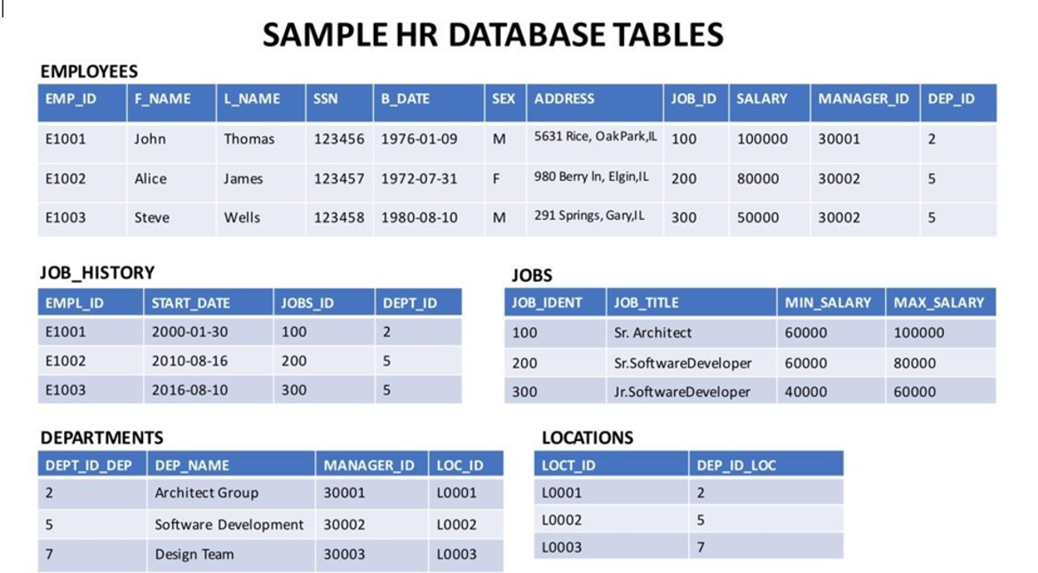

**Download the files in the links below to your local machine (if not already done in previous labs).**[Departments.csv](https://cf-courses-data.s3.us.cloud-object-storage.appdomain.cloud/IBMDeveloperSkillsNetwork-DB0201EN-SkillsNetwork/labs/Labs_Coursera_V5/datasets/HR_Database/Departments.csv)  
[Jobs.csv](https://cf-courses-data.s3.us.cloud-object-storage.appdomain.cloud/IBMDeveloperSkillsNetwork-DB0201EN-SkillsNetwork/labs/Module%202/data/Jobs.csv)  
[JobsHistory.csv](https://cf-courses-data.s3.us.cloud-object-storage.appdomain.cloud/IBMDeveloperSkillsNetwork-DB0201EN-SkillsNetwork/labs/Module%202/data/JobsHistory.csv)  
[Locations.csv](https://cf-courses-data.s3.us.cloud-object-storage.appdomain.cloud/IBMDeveloperSkillsNetwork-DB0201EN-SkillsNetwork/labs/Module%202/data/Locations.csv)  
[Employees.csv](https://cf-courses-data.s3.us.cloud-object-storage.appdomain.cloud/IBMDeveloperSkillsNetwork-DB0201EN-SkillsNetwork/labs/Module%202/data/Employees.csv)

**Questions:**

1. **Retrieve all employees whose address is in Elgin,IL**
2. **Retrieve all employees in department 5 whose salary is between 60000 and 70000.**
3. **Retrieve a list of employees ordered by department ID.**
4. **For each department ID retrieve the number of employees in the department**
5. **For each department retrieve the number of employees in the department, and the average employee salary in the department..**
6. **For each department retrieve the number of employees in the department, and the average employee salary in the department and limit the result to departments with fewer than 4 employees.**

# Hands-on Lab: Built-in Functions

create table PETRESCUE (

ID INTEGER NOT NULL,

ANIMAL VARCHAR(20),

QUANTITY INTEGER,

COST DECIMAL(6,2),

RESCUEDATE DATE,

PRIMARY KEY (ID)

);

insert into PETRESCUE values

(1,'Cat',9,450.09,'2018-05-29'),

(2,'Dog',3,666.66,'2018-06-01'),

(3,'Dog',1,100.00,'2018-06-04'),

(4,'Parrot',2,50.00,'2018-06-04'),

(5,'Dog',1,75.75,'2018-06-10'),

(6,'Hamster',6,60.60,'2018-06-11'),

(7,'Cat',1,44.44,'2018-06-11'),

(8,'Goldfish',24,48.48,'2018-06-14'),

(9,'Dog',2,222.22,'2018-06-15')

;

**Questions Aggregate Functions:**

**Query A1: Enter a function that calculates the total cost of all animal rescues in the PETRESCUE table.**

**Query A2: Enter a function that displays the total cost of all animal rescues in the PETRESCUE table in a column called SUM_OF_COST.**

**Query A3: Enter a function that displays the maximum quantity of animals rescued. Query A4: Enter a function that displays the average cost of animals rescued.**

**Query A5: Enter a function that displays the average cost of rescuing a dog.**

**Questions Scalar and String Functions:**

**Query B1: Enter a function that displays the rounded cost of each rescue.**

**Query B2: Enter a function that displays the length of each animal name.**

**Query B3: Enter a function that displays the animal name in each rescue in uppercase. Query B4: Enter a function that displays the animal name in each rescue in uppercase without duplications.**

**Query B5: Enter a query that displays all the columns from the PETRESCUE table, where the animal(s) rescued are cats. Use cat in lower case in the query.**

**Questions Date and Time Functions:**

**Query C1: Enter a function that displays the day of the month when cats have been rescued.**

**Query C2: Enter a function that displays the number of rescues on the 5th month.**

**Query C3: Enter a function that displays the number of rescues on the 14th day of the month.**

**Query C4: Animals rescued should see the vet within three days of arrivals. Enter a function that displays the third day from each rescue.**

**Query C5: Enter a function that displays the length of time the animals have been rescued; the difference between todays date and the rescue date.**